**Introduction to Game Software Development**

**" supreme plumber " design document**

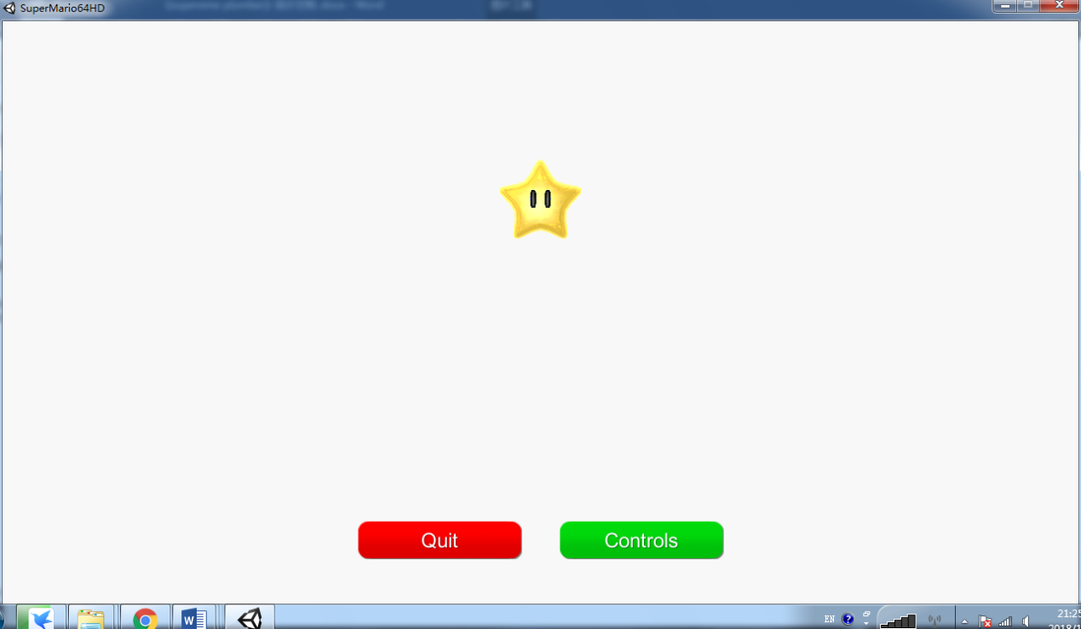

Game name: **supreme plumber**

Class: Class 1601, Computer Science and Technology (Inter-school Exchange), Department of Computer Science

Name: Chen Haorui

Student ID: U20161 2696

* **game concept**

" supreme plumber " is a 3d single player action game.

* **Game brief**

This game is a 3D single player action game. Players need to control a plumber in a 3D environment to explore the world of Hakoniwa . The world is closed, but players are allowed to explore at will. The world of Hakoniwa is full of enemies that attack the plumber , as well as creatures that offer aid, information, or ask for assistance. Players can obtain gold coins by killing monsters or other methods.

There are some special promotions in the world that can be used to enhance the player's abilities. For example, the wing cap allows the player to fly in the air for a period of time, and the metal cap allows the player to sink to the bottom of the water and walk without being affected by lack of oxygen.

* **Target population**

This game is an action game. There is no limit to the crowd, and the target audience is broad. Suitable as a casual game, puzzle game, used to decompress and relax after studying and working.

* **figure**

1. hero image

wearing a red beret , white gloves , and blue overalls collects gold coins by exploring the map , avoids or kills monsters , and finds the way to the end. A plumber can walk, run, jump, squat, crawl, flip, lunge, climb, kick, punch, or swim. Players can also combine jumps with other moves to perform special jumps. Other special moves include wall jumping, flying, and more . Players can also lift or push certain objects to solve puzzles. In water, plumbers also need oxygen, so they must surface regularly to breathe.

The following is a demonstration of specific actions:

normal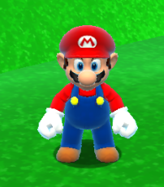 Forward rush (default march+S pace+Enter key)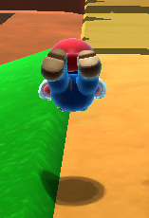

Squat (Default W key)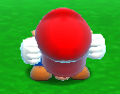 Kick (default Space+Enter key)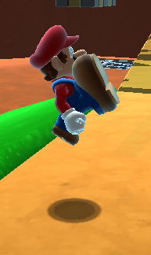

Jump (default Space key )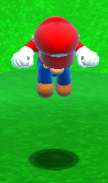 Boxing (Default Enter key )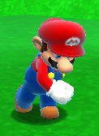

Somersault ( default Space+ left Ctrl key )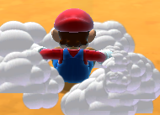

The protagonist does not have any special abilities or skills.

1. hero status bar

Located in the upper right corner of the game interface is a disk health bar divided into eight grids . Different types of damage will deduct different numbers of blood volume. When the blood volume is 100%-75%, it will display blue, when it is 75 % -50 % , it will display green, when it is 50 % -25 % , it will display yellow , 25% % -0 % (not included) shows red when the blood volume is empty, dies when the blood bar is empty, and returns to the menu.

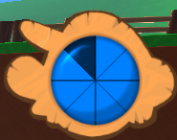 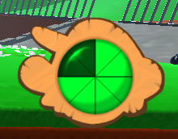 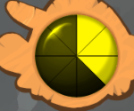 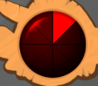

Three , the enemy

1. Mushroom Monster 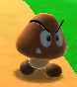: Wander around in a fixed area when in standby . When encountered in non-attack mode, one blood will be deducted . When the plumber enters its field of vision, it will accelerate and impact the player , and one blood will be deducted every time it is impacted . Can be killed with any attack method .

2. Bomb Monster 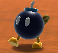: Wander around in a fixed area when in standby . No HP will be deducted when encountered in non-attack mode . When the plumber enters his field of vision, he will speed up and continue to track the player, and will explode within a few seconds . You can use any attack method to kill it , and you can also use the speed of the plumber to escape its damage range and disappear after it explodes.

3. Water cannonballs : Launched by several cannons in Hakoniwa World , they will fall from the sky and track the plumber for a certain period of time , and finally explode . If you are hit by a shell or blown up, you will lose two blood blocks.

* **player character**

control the plumber in the game . While defeating enemies , opening mechanisms , and collecting gold coins, players also explore four areas of the map , and finally reach the end.

* **game world**

1. overall appearance:

Take the first act , for example. The background of the background control interface (see the game mechanics section ) is the game's world map. It can be seen that the Hakoniwa world is roughly divided into four areas , one is the bottom area (area 1), the second is the right side of the middle area (area 2), the third is the left side of the middle area ( area 3 ) , and the fourth is Pingdingshan ( area 2) . d ) . Areas 1 and 2 are connected by a slanted bridge and an elevator; Areas 1 and 3 are connected by secret doors ( you need to press the door to open in Area 3) ; Areas 1 and 4 are not connected ; Area 2 Area 3 is connected by a bridge; area 2 and area 4 are not connected; area 3 and area 4 are connected by a small gate on the iron fence. These connection points are also the critical paths of the entire map.

The picture below is the starting point of the game , located in area 1.

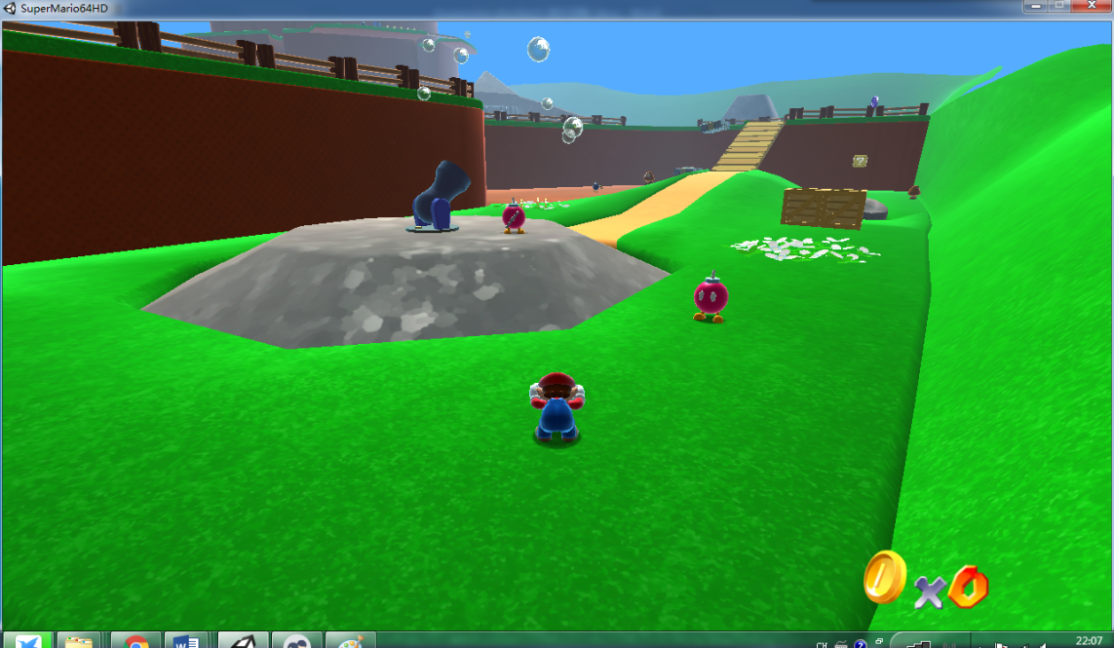

The picture below is the end of the game, located on the top floor of area four.

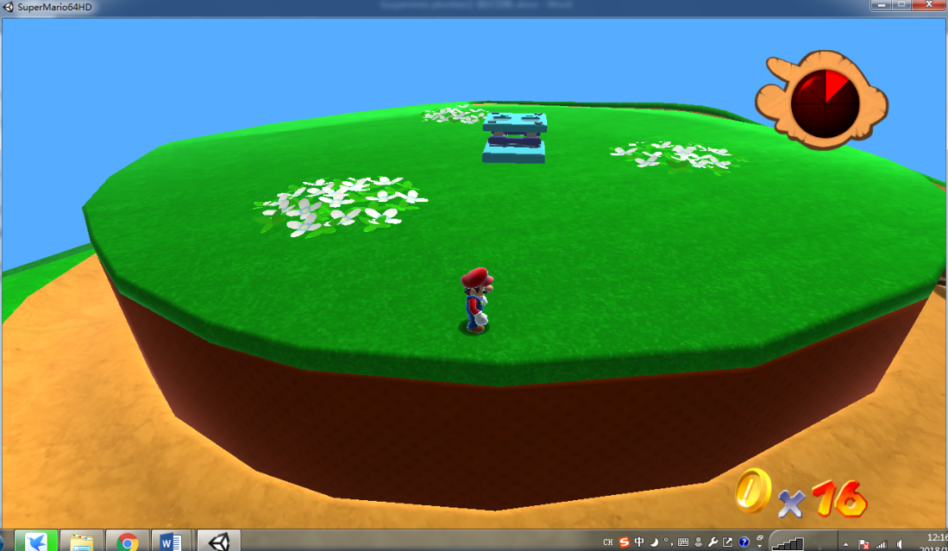

Game screenshot :

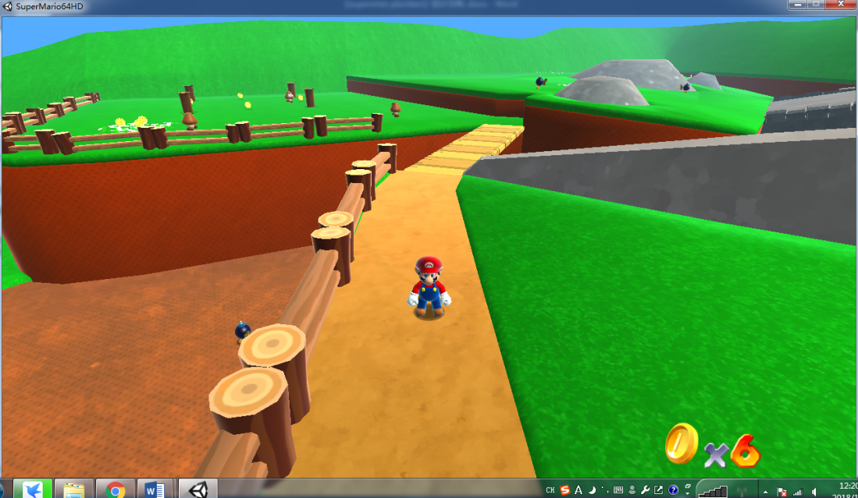

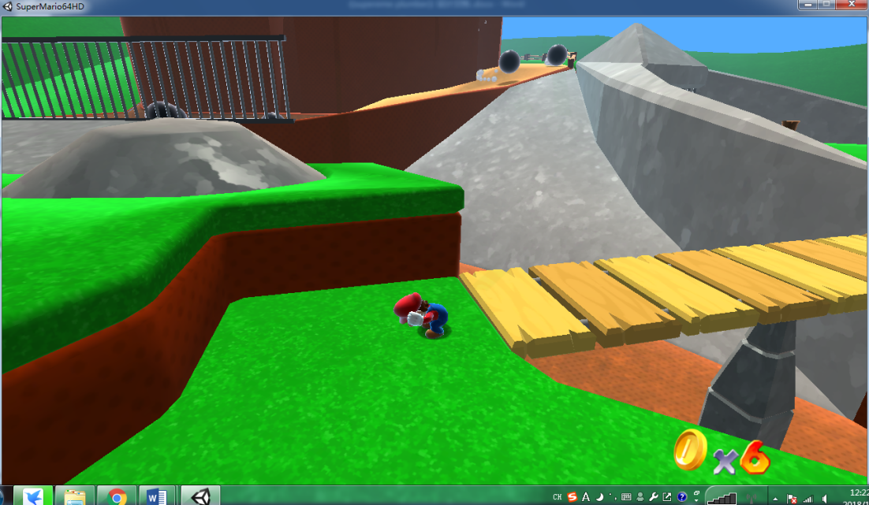

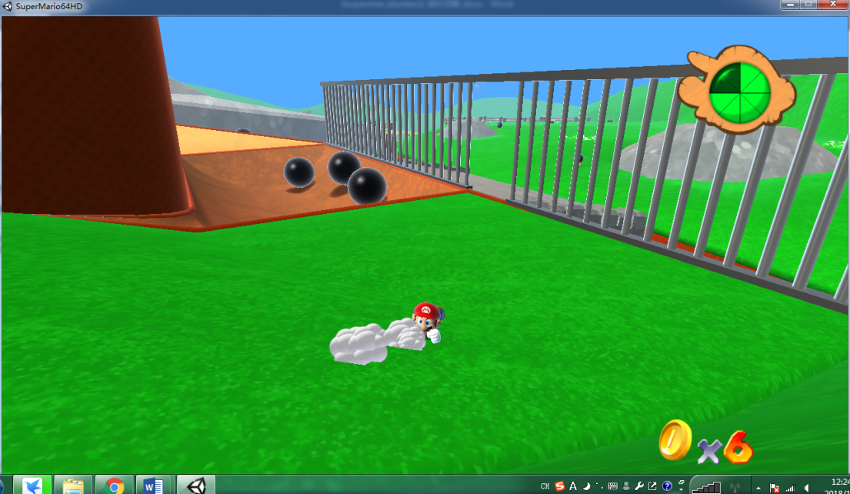

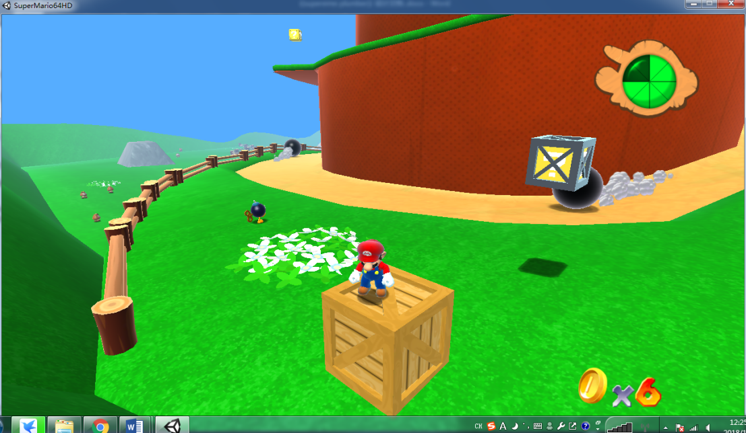

2. Number of gold coins: located in the lower right corner of the game interface. Displays the number of coins currently collected. It can be grown by collecting normal gold coins or special gold coins . Ordinary gold coins can be obtained by collecting in the map, killing monsters or breaking blocks 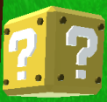. It is difficult to obtain special gold coins , and you need to use certain special methods or skills to obtain them. Obtaining a gold coin can restore one bar of blood at the same time ( when the blood bar is not full ) .

3. Organs:

1. Harmful organs :

(1) Cannon 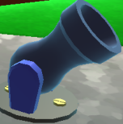: It will fire water cannonballs in a specific area, and it will not cause any damage . Water cannonballs have been introduced in the enemy section, so I won't repeat them here .

(2) Stone ball road 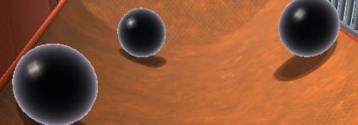: There will be stone balls rolling down from the sides or the front of the road, you need to avoid on both sides of the road , if you are run over by the stone balls, you will lose 2 blocks of blood .

2. Incentive institutions :

(1) Cellar well 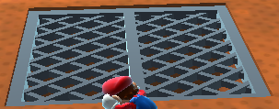(2) Railing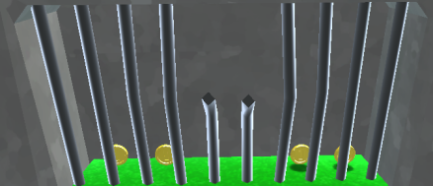

There are gold coins in the two organs . Lead the bomber to the organ to detonate to open it to get gold coins .

3. Other agencies :

(1) Secret door: Entering from the remote passage in the three corners of the area , you can go around to its switch, step on the switch, and the door will be opened. Before opening the door : 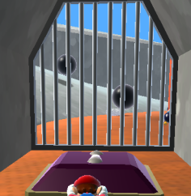 After opening the door :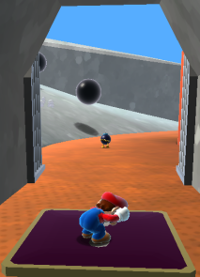

(2) Elevator : 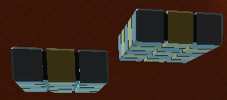Scroll up and down to send the player to a high place .

(3) Portal : There are two ways of existence, one is yellow flowers , there is a group in the map ; the other is stone cave, there is a group in the map . The Stone Cave acts as a stone ball generator in area four when it is not visible to the player .

Yellow bushes: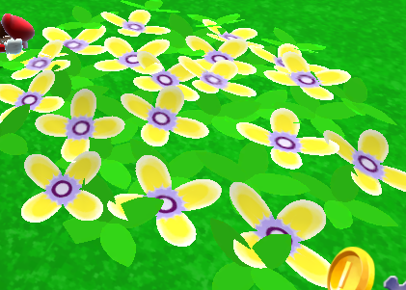 Cave :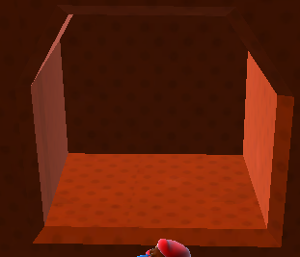

(4) Bridge : 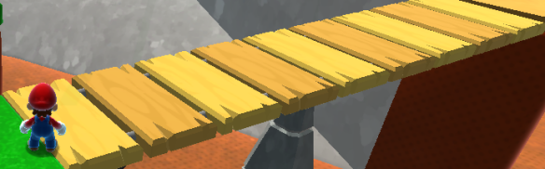There is only one fulcrum , which is extremely unstable and needs to be passed as soon as possible.

1. Visual and auditory experience:
2. vision :

painting , the entire game is in the style of Japanese cartoons , with exaggerated yet cute characters . For example, the protagonist plumber's red beret, mustache and big nose can all leave a deep impression on people. The shape of the monsters in the game is simple , the color matching is reasonable , and the characteristics are distinctive . The game scenery is mainly yellow-brown, green and gray. While enriching the color of the game world, the color matching is reasonable, so as not to dazzle the player or cause the player 's visual fatigue.

In terms of animation, the movements of the characters in the game are smooth and there is no lag. When the protagonist runs, there is a visual effect of raising dust behind him. When the bomb/cannonball explodes, there is a corresponding animation. When the stone ball shatters, it can be seen that it is broken into pieces During the process , the gold coin will rotate in the scene to identify itself . When the monster locks on to the protagonist and pursues the attack, the Mushroom Monster has a slight head swing , the fuse behind the bomber has an accelerated burning effect , and there is a significant increase in volume before the explosion . There is a corresponding increase or decrease of the shadow , and the monster has the effect of turning to dust and randomly popping gold coins when it is eliminated. When the plumber fires a cannon at close range , the screen will vibrate briefly. When the plumber is attacking ( such as kicking ) , there will be a corresponding exaggerated zoom- in animation on the attacking part. After falling from a high place, there will be a short forced stiff state accompanied by a dizzy effect with stars around his head ( two blood blocks will be deducted at the same time ) .

1. Hearing :

The processing of auditory effects in the game is more detailed. The background music style is lively and lively , and it is a cycle of multiple background music instead of a single background music , which matches the overall visual impression of the game. All events in the game are matched with corresponding sound effects , such as the sound of the protagonist falling to the ground, the sound of the stone ball rolling, the sound of the protagonist sliding down the slope , the sound of collecting gold coins, the sound of the cannon firing , the sound of the bomb /cannonball exploding, and the stone ball shattering The sound of the transmission process . The protagonist will also be accompanied by shouts such as " hey " and " ha " when making various actions .

All visual and audio materials in the game can be found in the project project folder.

* **game mechanics**

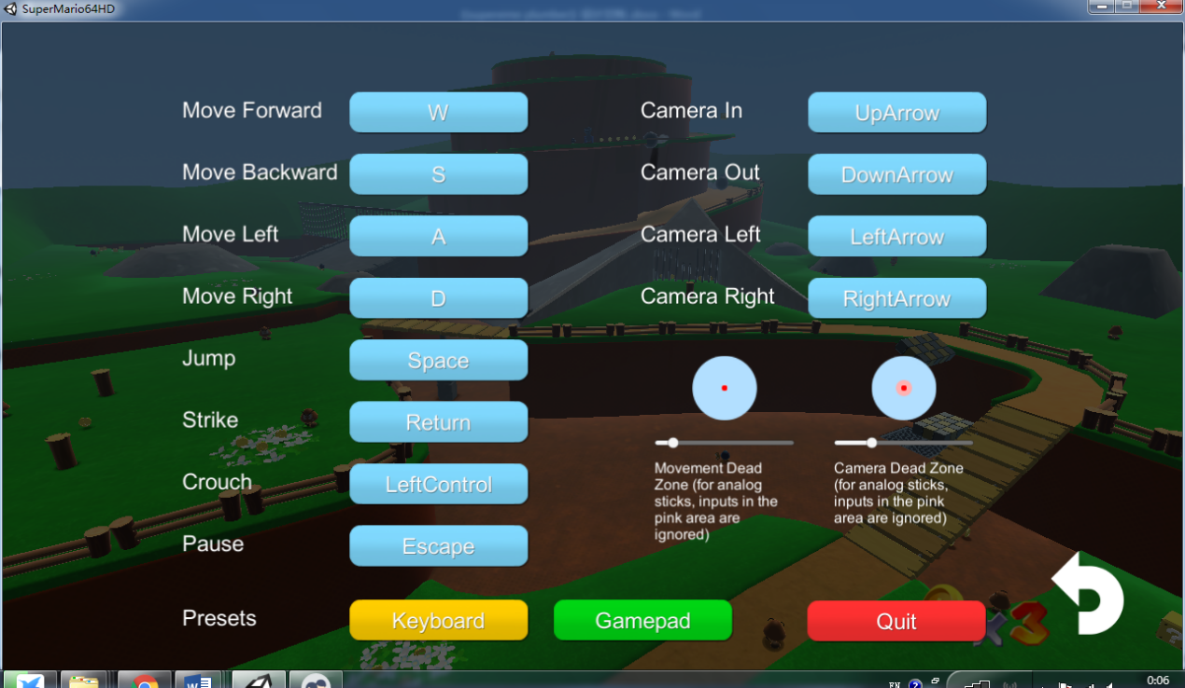

The picture above is the background of the game control (it is also the pause screen ). This interface can be entered by clicking the Controls key in the main menu before entering the game , or by pressing the E sc key after entering the game . In the menu part, the operation is mainly completed by the mouse ; in the game , all operations are completed by the keyboard . Among them, the plumber's movement defaults to the classic w sa d four-key control; take-off is the Space key , attack is the Enter key, and squatting is the left Ctrl key. The above button combinations can trigger different actions of the plumber, see the "Player Character" section for details . ↑↓←→Keys control the character's field of vision , where ↑ is zooming in, ↓ is moving away , ← is rotating counterclockwise , and → is rotating clockwise . The above keys operated by the keyboard can be changed by clicking the mouse . Click the Quit key to exit the game and return to the main menu.

The game is more adventurous , so combat isn't its main mechanic . Nevertheless , the battle is not a simple turn-based system but a street mechanism. Players need to find the right time to counterattack and destroy the enemy while avoiding the enemy's indeterminate methods and indeterminate attacks. The game is won when the end point shown in the game world section is reached .

* **Overall system structure**

This project is divided into two scenes : StarMenu.unity is the menu interface , BobOmbBattlefield.unity is the game interface.

The original interface contains 7 types of game objects, namely Actors (movable objects), DoodAds (cannons and fences ), Effects (visual effects attached to the game body ), Interactive ( protrusions and gold coins on the background ), Paths ( enemy's trajectory ) , Sounds ( sound ) , UI (game interface).

Improved design includes the manager design game body InputManagerController .

* **kind**

